Theory section

Introduction

I_{b} - Design current
I_{n} - Protective size
I_{z} - current-carrying capacity (with all corrections)
I_{t} - current-carrying capacity.

Z_{s} = Z_{e} + (R₁ + R₂)

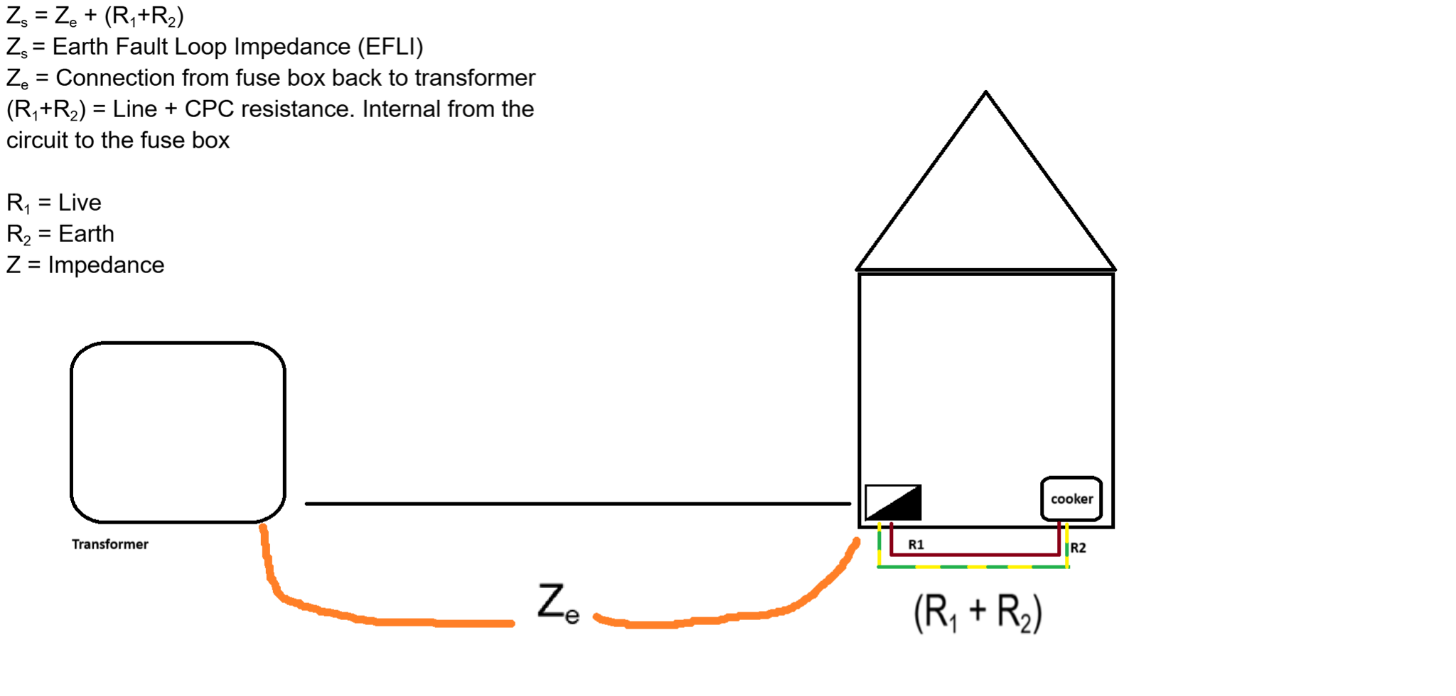

Question:

A 230 V 4kW load is to be wired in non-armoured single-core 70°C thermoplastic insulated copper conductors wired in steel conduit installed on the surface some 25 metres from the distribution board. Three other similar circuits are installed in the same conduit which passes through an area where the ambient temperature reaches 40°C. Calculate the cross-sectional area of cable required if protection is by a BS288-2 fuse. Show all working.

Working out:

Voltage (V) - informs us what kind of circuit or power supply is needed
Kilowatts (kW) - informs us of how much power is consumed or required
(Used ChatGPT to get these definitions)

- I_{b} -> design current

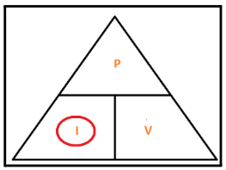

I = P/V
4,000/230 = 17.39 A

We do not calculate the diversity rule because the full load is not specified.
I_{b} = 17.39 A

2) I_{n} -> Protective device

I_{n} = 20 A

3) I_{t} - Current carrying capacity

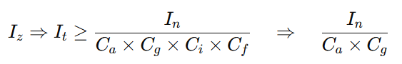

C_{a} => Ambient temperature.

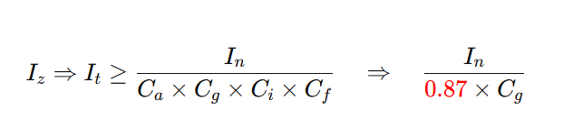

The ambient temperature is defined as the air temperature surrounding a particular object or area. The question states that “the ambient temperature reaches 40 °C”. The questions also states “thermoplastic 70°C insulated copper conductors”

 | Insulation
 |  |  | Mineral
Ambient temperature | 70°C thermoplastic | 90°C thermosetting | Thermoplastic covered or bare and exposed to touch 70°C thermoplastic | cBare and not exposed to touch 105 °C
25 | 1.03 | 1.02 | 1.07 | 1.04
30 | 1.00 | 1.00 | 1.00 | 1.00
35 | 0.94 | 0.96 | 0.93 | 0.96
40 | 0.87 | 0.91 | 0.85 | 0.92
Table F1 Page 168

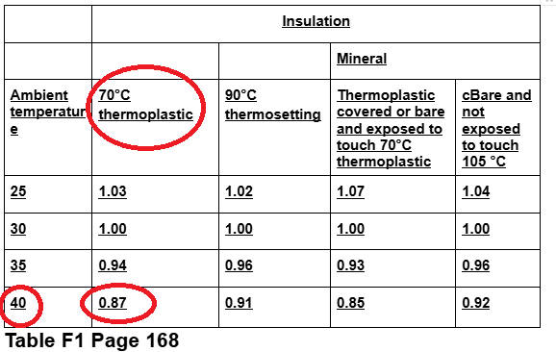
Therefore, using the table the answer for C_{a} is 0.87.

C_{g} => grouping
“Three other similar circuits are installed in the same conduit …”

Number of circuits or multi-core cables
Arrangement (cable touching) | 1 | 2 | 3 | 4 | 5 | 6 | 7 | 8 | 9 | 12 | Applicable reference method for current-carrying capacities
Bunched in air, on a surface, embedded or enclosed | 1.0 | 0.80 | 0.70 | 0.65 | 0.60 | 0.57 | 0.54 | 0.52 | 0.50 | 0.45 | A to F
Single layer on wall or floor | 1.0 | 0.85 | 0.79 | 0.75 | 0.73 | 0.72 | 0.72 | 0.71 | 0.70 | 0.7 | C
Single layer multicore on a perforated horizontal or vertical cable tray system | 1.0 | 0.88 | 0.82 | 0.77 | 0.75 | 0.73 | 0.73 | 0.72 | 0.72 | 0.72 | E
Single layer multicore on a cable ladder system or cleats etc | 1.0 | 0.87 | 0.82 | 0.80 | 0.80 | 0.79 | 0.79 | 0.78 | 0.78 | 0.78 | E

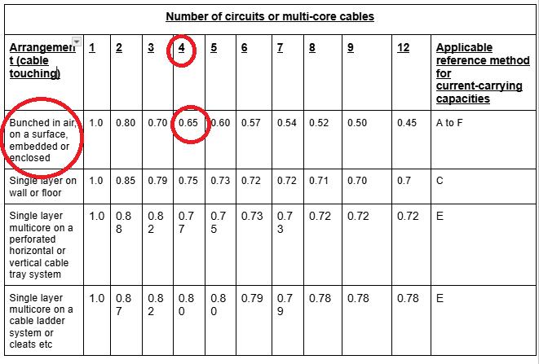

I_{t} = 37.37 A (Current carrying capacity without corrections)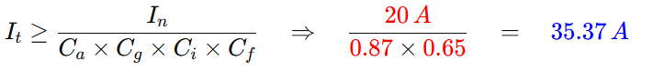
When you see the voltages 230V or 400v just remember:
- 230V - single phase systems
- 400V - three phase systems.

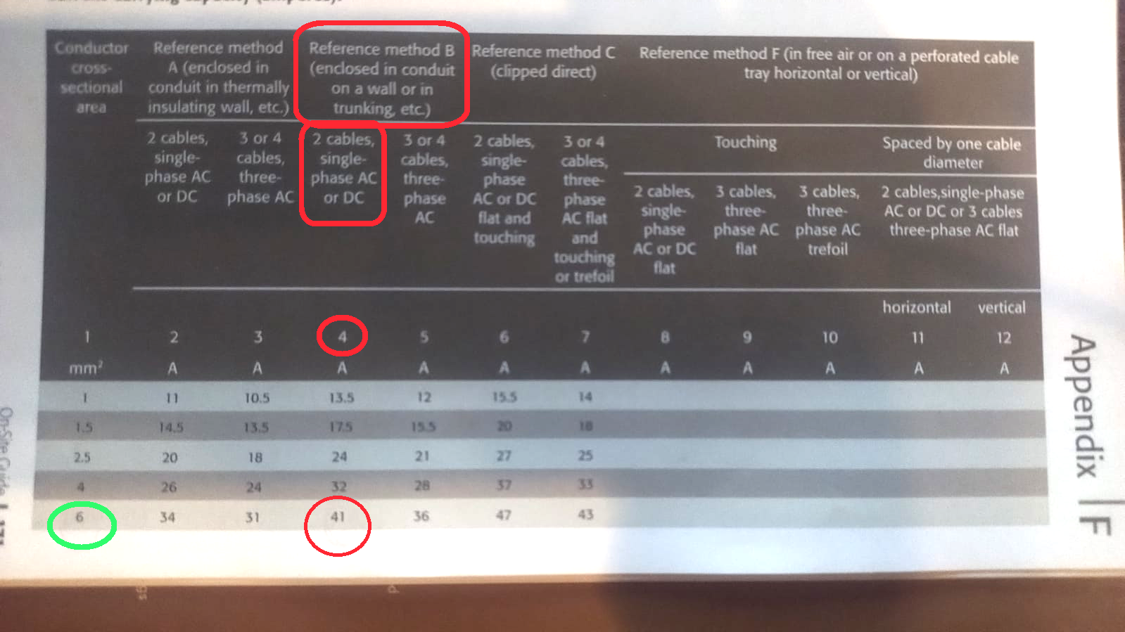
Table F4(i) - page 171

We used the above table to deduce the I_{z} value.
Remember that we deduced I_{t} to be 35.37 A.
If we round this up, 41 is the next number (circled in red above)
The question states 230V - which means it is a single phase system
The question states “enclosed into the same conduit” “..installed onto the surface”.
The answer highlighted in green, shows that we need a 6mm² cable size. 6mm² cable corresponds to a 41 A which is enough.

I_{z} = 6 mm²

Voltage drop

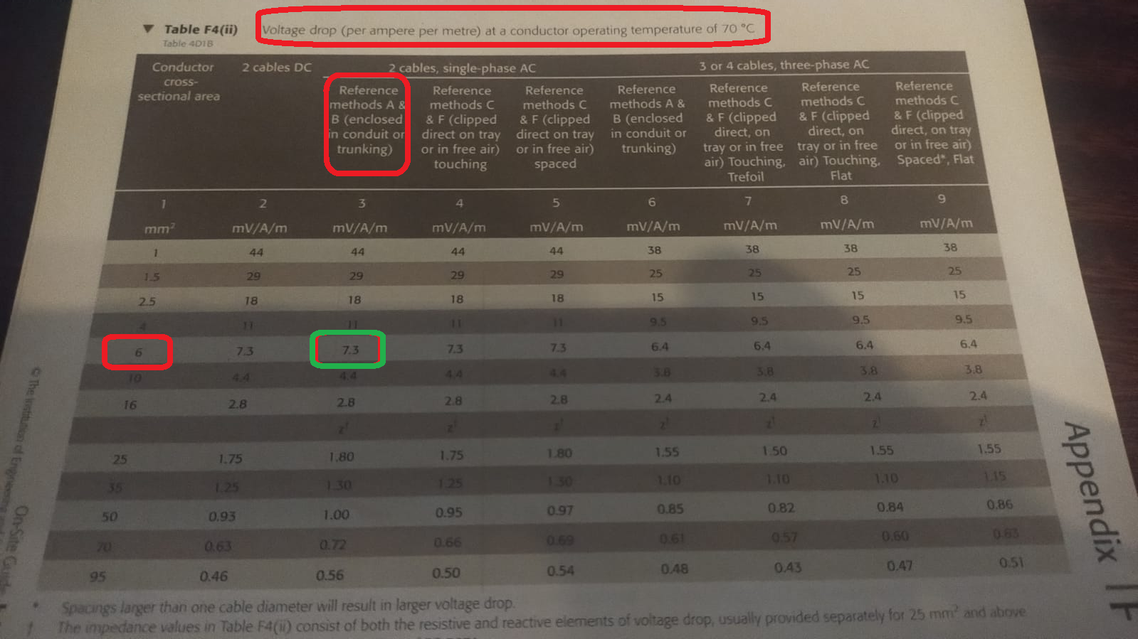
Table F4(ii) page 173

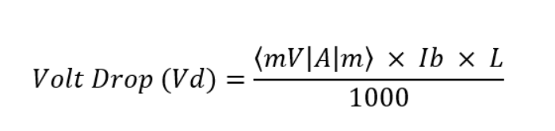

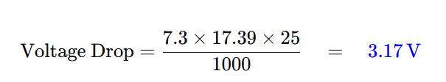

Practical section

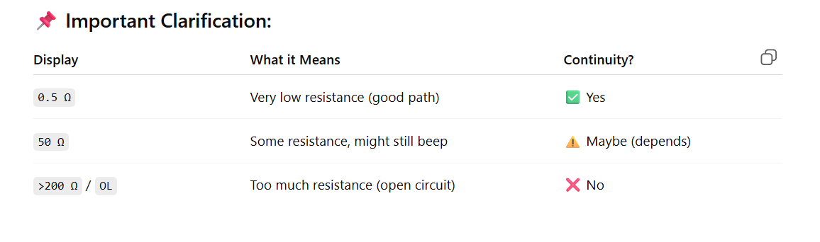
In the board below we also installed a radial circuit - which is highlighted in green.

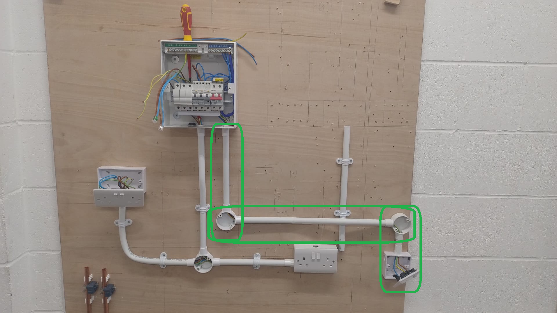

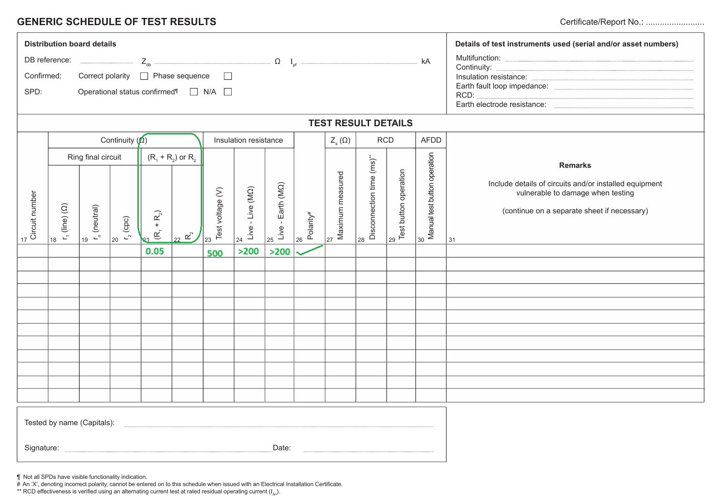

Test for a Radial circuit

Step One - test for Continuity (Ω)

(R₁ + R₂)
R₁ = Live and R₂ = Earth
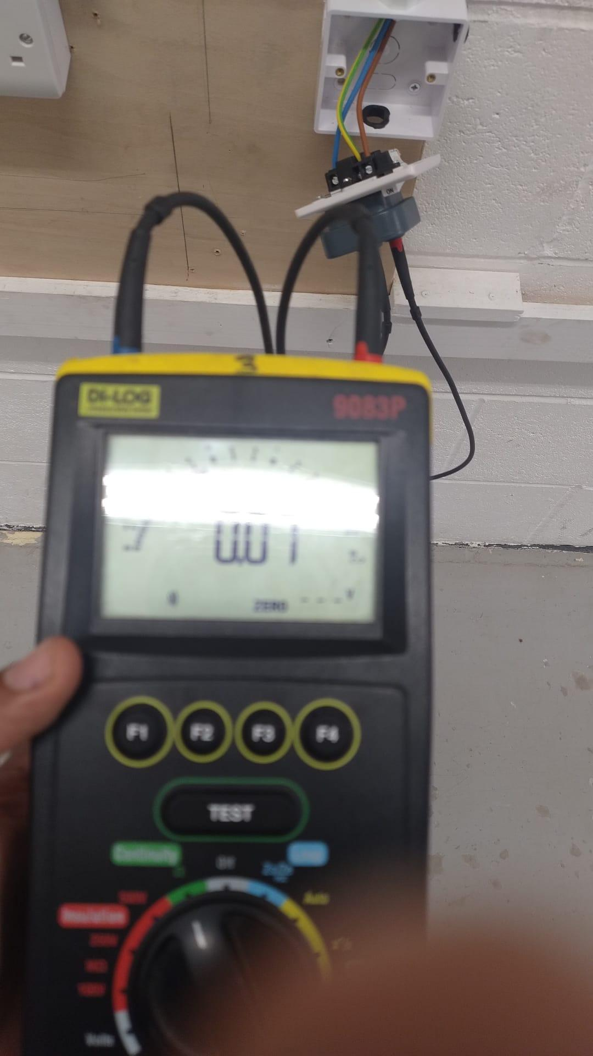

- Set-up electrical tester for continuity test:
- Set the dial on the electrical tester to the “continuity” setting;
- Plug the tester socket into the plug;
- Attach the probes into the Live and Earth socket pins.

- In terms of the Fuse board:
- Put the Earth wire into position two of the connector block;
- This is because the circuit that we wish to test is on the second RCD;
- The live wire can go anywhere in the connector block.

As a result of following part A and part B we create a loop in the circuit. A loop in which the electrical current flows down the brown live wire and back through the green and yellow earth wire.

C) Hit the test button on the electrical tester - interpret the result:

- First reading was 0.05 Ω (Ohms)
- Second reading of 0.07 Ω (Ohms).

- This means that there is very little resistance in the circuit.
- When there is little resistance this means there is a good flow of current.
- Continuity checks if there is a connection between two points.

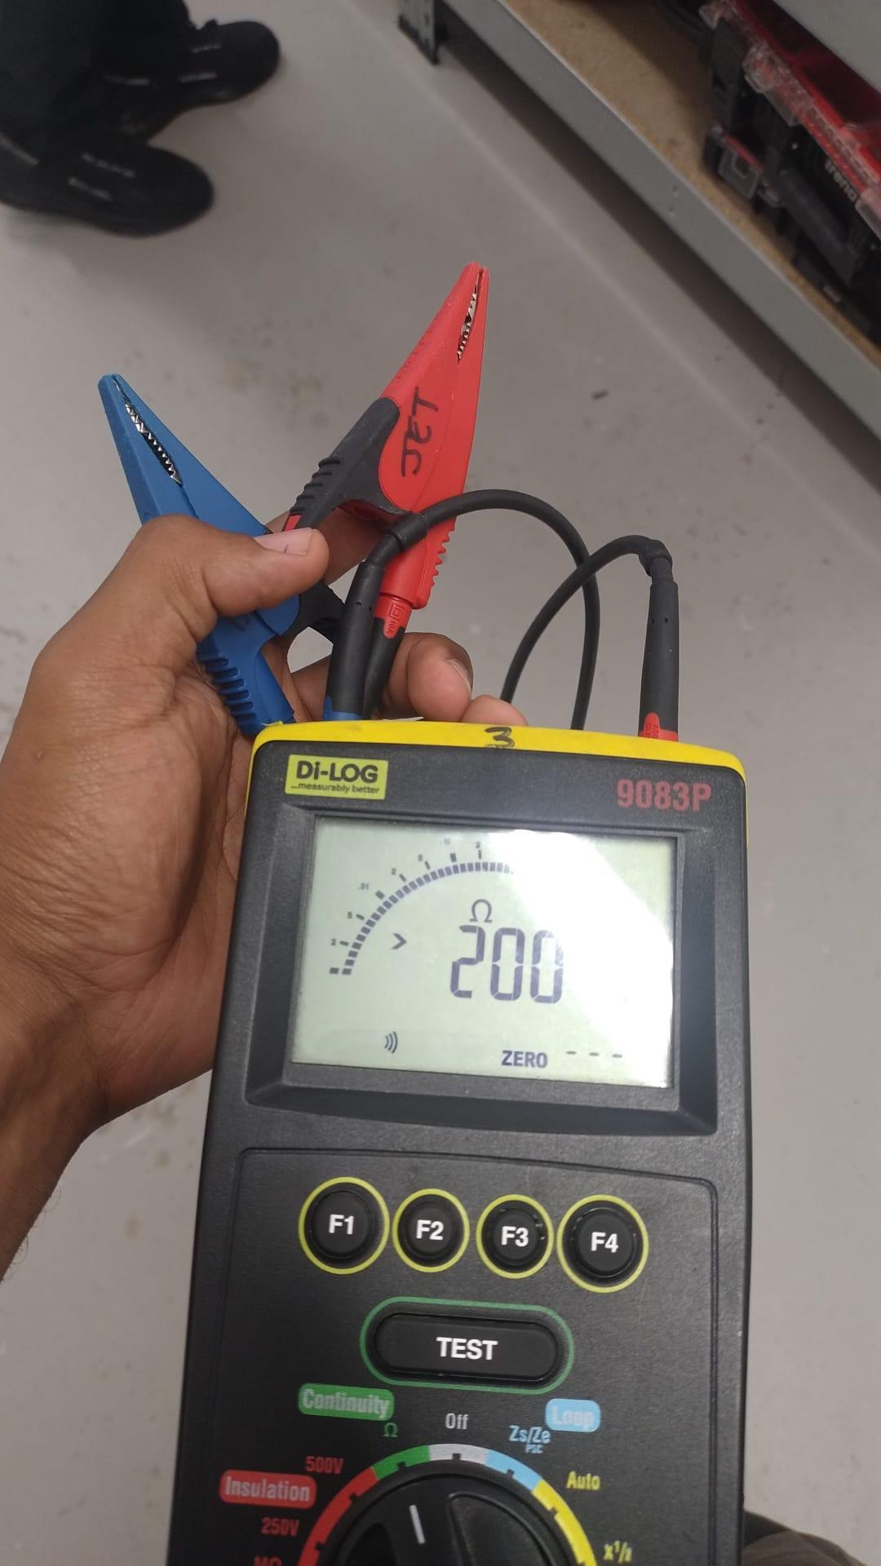

>200 Ω or there around - means no continuity or an open circuit. Resistance is too high to even measure.

Insulation resistance

Step Two - Test voltage (V)

Set the test voltage to 500 on the machine.
Write 500 on the test sheet because this is the voltage level.

Step Three - Live - Live (MΩ)

Means we test the brown live wire and the blue neutral wire.
We scored > 200Ω Ohms.
This test means that the brown live wire and the blue neutral wire do not touch each other in the radial circuit.
Does this score mean that because there is so much resistance the wires (brown live wire and the blue neutral wire) simply cannot be touching. Because if they were touching the resistance would be lower as there would be more current flow.

Step four - Live - Earth (MΩ)

Test the brown live wire and the earth wire. We got >200 Ω (Ohms) which means the wires are not touching.

Step five - Polarity is ticked because we got a reading in Part One subsection D.

